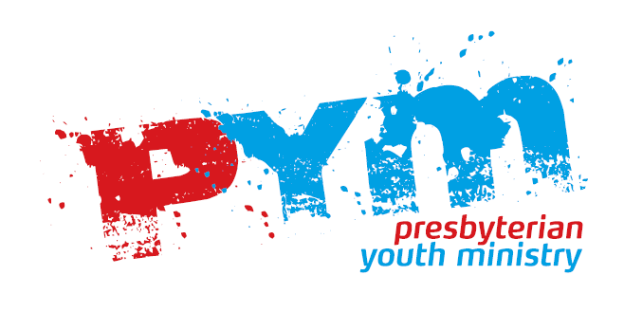
Permission Form
Event:
Starting Time:
Ending Time:

Section A - Personal Details

First Name Middle Name Last Name
Address
Mailing Address If Different
Email address | Date Of Birth
Daytime Phone | Date Of Birth
Daytime Phone | Age
Evening Phone | Age
Evening Phone | Male / Female
Mobile Number | Male / Female
Emergency Contact Details

Section B – Medical And Child Protection

Special Medical Needs (eg Asthma, Diabetes)

Special Dietary Requirements
Doctors Contact Details
Section C– Permission

Signature | Date
By signing; I understand that in the event of an emergency I have given permission for the youth leader to act in the safety interests of my child. I understand that every attempt will be made to contact me first before any decision is made regarding treatment or medication.

I Understand images/videos of my child may be taken, and from time to time they may be used for promotional purposes.

If you are unhappy with this please tick here.

