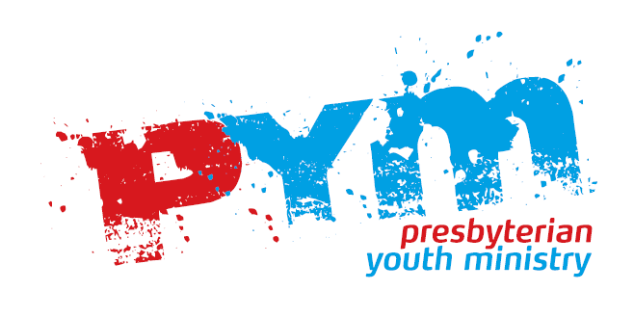
Risk Assessment and
Management Form

Ministry / Group Knox Youth Group |  |  |  | Date/Time 12/12/12
Location Knox Park |  |  |  | Leaders Name John Knox
Activity Tramp |  |  |  | Number of Leaders 3
Analysis |  | Description
Risks  Accident, injury, damage |  | Physical injury  - Minor (cuts, scrapes)  - Moderate (broken bones, sprains)  - Major (hypothermia)  Getting Lost  Emotional Trauma
 |  | People | Equipment |  | Environment
Casual  Factors  Hazards, perils, dangers |  | 1.Leader could negotiate track incorrectly  2. Young person could wander from the main group. | 1. Lack of adequate clothing and footwear. |  | 1. Weather could turn bad.
Risk Management | Normal Operations | 1.Take and refer to map/ Leader walk track prior to trip.  2. Set clear boundaries beforehand. Have leaders dispersed through group. Count young people when stopped for breaks | 1 Issue comprehensive gear list. Check gear before leaving. |  | 1. Check weather forecast beforehand, cancel trip if forecast looks bad. All participants take warm/wet weather gear.
Risk Management | Emergency | Take 1st Aid Kit  Person trained in First Aid to  participate in the walk  Adequate leaders in case one  needs to walk out to get help
Relevant Industry Standards Applicable |  | National Youth Workers Network Aotearoa Code of Ethics  PYM “Safety in Youth Ministry” Booklet
Skills required by staff |  | 1st aid certificate  Group management
Final Decision  on Implementing activity |  | Form Completed by John Knox
Choose one:
YES NO
 |  | Approved by Rev Calvin
 |  | Position in Church Minister |  |  | Date 11/11/12

